History

The Grande Prairie Residential Society (340715 ALBERTA SOCIETY) is non-profit organization run by a dedicated volunteer board made up of community members and tenants. GPRS was formed in 1986 by a local group of individuals who saw a need for housing in northern Alberta for people with physical disabilities. The group included people with disabilities and their families, along with supporters in the health and business community. The Grande Prairie Residential Society has built three major housing projects since 1986, which the Society continues to operate. The provincial and federal governments have provided funds toward the building of all three GPRS projects. The Society has also had generous financial support from local community organizations, businesses and individuals.

As the need for accessible, affordable housing continues to grow in our community, GPRS remains dedicated to finding creative solutions to meet the housing needs of the future.

Eligibility Criteria for GPRS Wheelchair Accessible Housing

Applicants must have a physical disability that impairs their mobility. Priority will be given to those who use wheelchairs and require wheelchair accessibility.
If applicants require personal support services, they must have their needs assessed and have a plan in place to obtain the needed services, prior to acceptance into the units.
Applicants must meet income criteria as set out by GPRS and must be willing to enter into a landlord-tenant agreement with the Society.
Applications are available for download from the GPRS website or from the Grande Spirit Family Housing Office at 9503-102 Ave. Grande Prairie, or call (780) 532-3276.

Website: www.gpresidentialsociety.com

If you would like more information or to give a donation, please call the GPRS housing manager at the Grande Spirit Foundation Family Housing Office, at (780) 532-3276.

**GPRS has a contract with Grande Spirit Foundation to manage and maintain their properties.**





Mission Statement

“To provide accessible and
affordable housing for people
with physical disabilities.”

Phase I - Duplexes

In 1987, GPRS built 5 duplexes in the Crystal Ridge area in Grande Prairie. They were the first wheelchair accessible housing units built north of Edmonton.

There are six 2 bedroom units and four 3 bedroom units. The outside doors are equipped with automatic openers. Hallways and doorways are wide enough for wheelchairs. Each bathroom has a wheel-in shower and a regular tub, with grab bars in necessary areas. Kitchens are wheelchair accessible, with such features as countertop stoves and wall ovens. Each unit has a washer and a drier.

These features make the duplexes truly accessible homes.

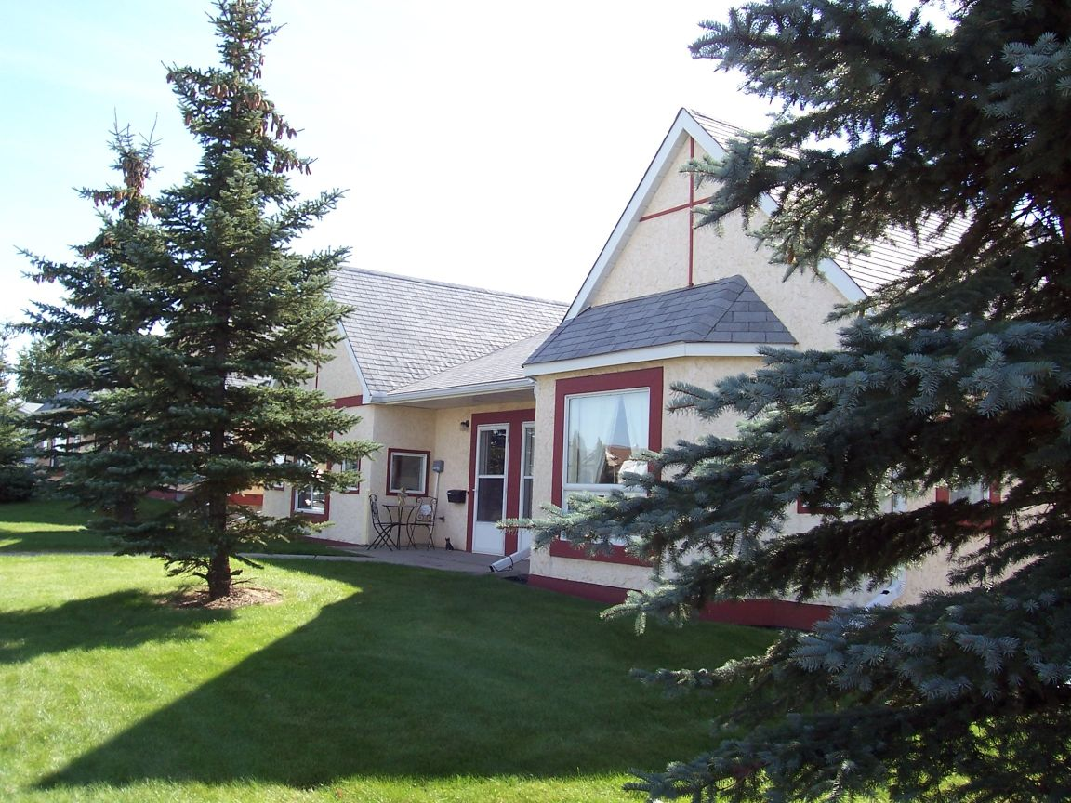

Phase II - 7 –Plex

The Six-Plex, a 7 unit apartment complex, was constructed in 1994 at 9609- 123 Avenue, next to Phase I. It was built to meet the growing need in the Grande Prairie area for additional affordable housing for people with physical disabilities.

Ground-level entrances are fully accessible with automatic doors, and, like the duplexes, hallways and doorways are widened. Each bathroom has a wheel-in shower. The kitchens are wheelchair accessible, with similar features to Phase I, including barrier-free cupboards and countertops. The accessible laundry room is shared by the tenants. There is also a built-in vacuum system for tenant use.

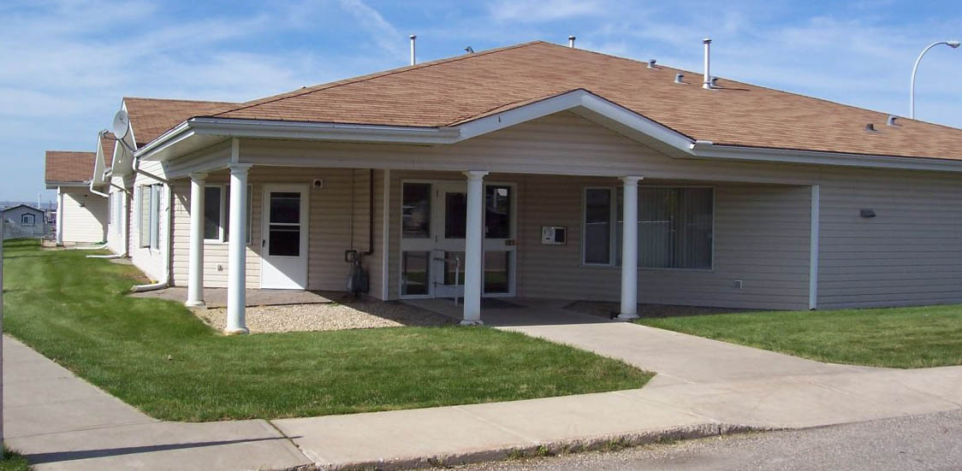

Margaret Edgson Manor

In 2005, Margaret Edgson Manor opened the doors to 16 wheelchair accessible units and 54 regular suites. Grande Prairie Residential Society joined with the City of Grande Prairie’s Global Housing Initiative, in a unique partnership, to provide affordable housing to meet a variety of needs. All units have two bedrooms, and the barrier free suites are equipped with similar features to our first two phases. Margaret Edgson Manor is a sustainable housing project, with no government assistance to operate.

The building was named for Margaret Edgson, who was a strong advocate for transportation and housing for people with disabilities. Her estate contributed significantly to the project.

